
Press Information

For Release: Immediately

Contact:
Kathryn Langley
Marketing Communications Manager, Motion Systems Group Europe
Phone: +44 (0) 7342 061 228
Email: kathryn.langley@parker.com
www.parker.com

Parker extends its range of P1V-A Series air motors

ATEX certification supports use in explosive environments

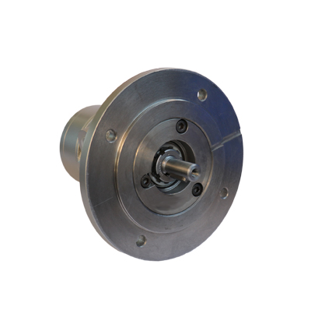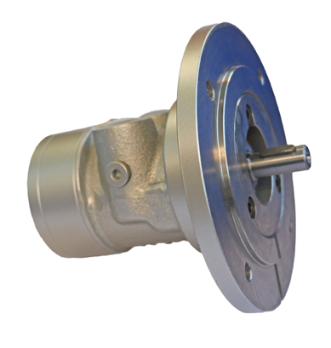

August 2017 – Parker Hannifin, the global leader in motion and control technologies, has extended its range of P1V-A Series reversible air motors with additional power ratings, including models with ATEX certification suited to use in explosive environment applications.

The new extended family of P1V-A Series of air motors features painted cast iron motor housings and sealed components to enable reliable operation in challenging, damp, dirty environments. The range contains six different sizes with power ratings ranging from 1,600 to 18,000 Watts.

The motors can be supplied either in basic form or with built-in gearboxes. Three types of gearboxes – planetary, helical or worm gears – are available for selection depending on the type of rotation and torque required in the application. A combination of face and base mounting options offer additional flexibility to system designers.

All of Parker’s P1V-A pneumatic air motors are equipped with spring loaded vanes as standard; this supports very good starting and low speed running characteristics. The simple, rugged construction of the motors makes them vibration, heat and impact resistant as well as enhancing reliability and speed and ease of servicing.

Air motors are better suited to some rotary power transmission applications than electric motors, especially when operating in harsh industrial environments. With their comparatively small dimensions and fewer moving parts, air motors are self-cooling and do not pose a sparking hazard. Unlike their electrical counterparts, they can be stopped and started repeatedly and even loaded until they stall without incurring any damage.

ATEX-certified versions for use in environments with an explosive atmosphere are available for four basic models without gearboxes: 1600, 3200, 5000 and 6000 Watts. The ATEX-certified motors can operate at ambient temperatures in explosive environments ranging from -20 to +40 °C and can withstand pressures spanning four to six bar.

-Ends-

Image Caption: Parker has extended its range of P1V-A Series reversible air motors with additional power ratings, including models with ATEX certification.

About Parker Hannifin
Parker Hannifin is a Fortune 250 global leader in motion and control technologies. For 100 years the company has engineered the success of its customers in a wide range of diversified industrial and aerospace markets. Learn more at www.parker.com or @parkerhannifin.

August 2017 Ref: PAREU635/AUGE275/A/ENG

