Ingeteam bags 170 MW inverter order for three PV plants in Morocco
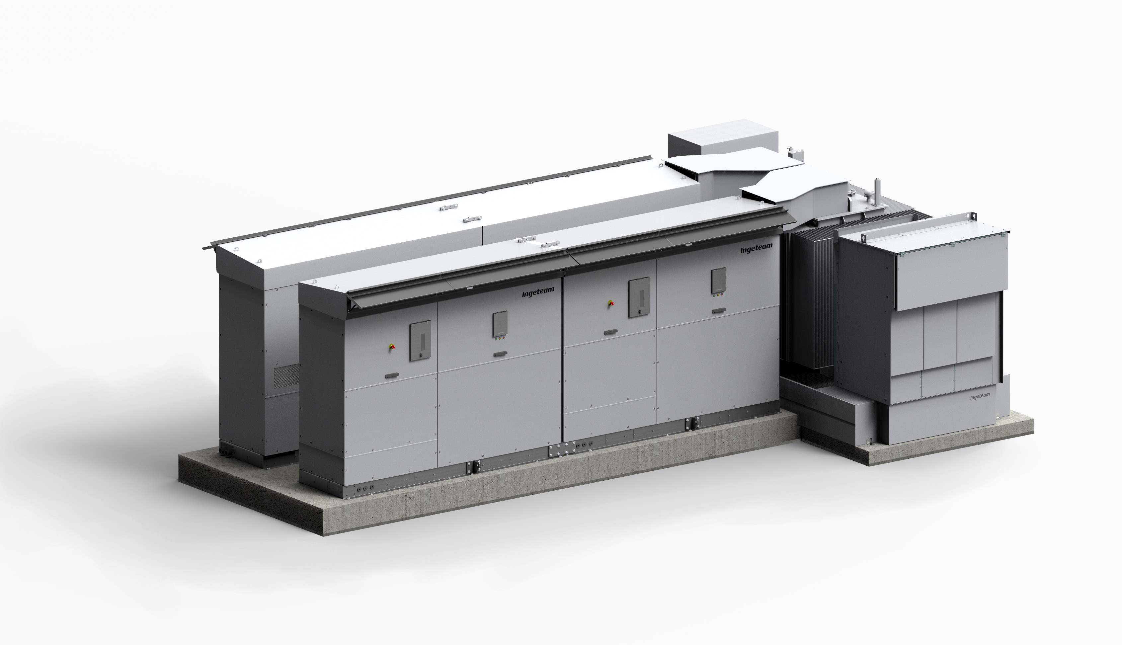
Spain. August 8, 2017. Ingeteam has commenced the supply of its equipment to three solar photovoltaic power plants in Morocco, totaling 170 MW of output power.
These three PV plants, which will be amongst the largest in North Africa, are expected to be operating within a year and to have a service life of at least twenty years.
The power produced is to be supplied to the Moroccan power distribution grid, serving to cover the energy demand of thousands of homes in Morocco. This will make it possible to slightly reduce the country's heavy reliance on foreign energy sources, given the fact that this North African country imports 90% of all the energy it consumes. The execution of this project comes within the framework of the target set by Morocco, to produce 52% of all its energy from renewable energy sources by year 2030.
The solution supplied, namely Inverter Station, features Ingeteam’s new dual photovoltaic inverters and a medium voltage skid that integrates all the necessary components in order to inject to the grid the solar output power after transforming it from low to medium voltage. Thus, the power transformer, the oil deposit, the medium voltage switchgear, the ancillary services transformer and the low voltage switchgear are supplied integrated into a single metal platform or skid.
Ingeteam’s dual PV inverters belong to the INGECON® SUN PowerMax B Series and are able to provide up to 2.55 MW at 1,000 Vdc. On the other hand, the 1,500 Vdc inverter version can supply up to 3.6 MW in a single 5,600 x 890 x 2,260 mm equipment, which makes it one of the market leaders in the field of power density thanks to its 317 kW/m³.
The solution supplied achieves up to 4.66 MW per Inverter Station, featuring dual inverters with 1,000 Vdc technology. These new inverters have been especially designed to withstand adverse ambient conditions.
On the other hand, in the African continent Ingeteam is responsible for the operation and maintenance of 230 MW divided into five different South African PV plants. Moreover, Ingeteam has been recently awarded the supply and commissioning of the protection, control and metering systems for three substations in Malawi.

Scope of supply
For this project Ingeteam is supplying:
- 35 inverter stations fitted with all the necessary equipment to inject medium voltage power: dual photovoltaic inverters, LV/MV transformer, medium voltage switchgear, auxiliary services transformer and low voltage switchgear.
- Commissioning of the system.
- Operation & Maintenance Service.

Ingeteam
Ingeteam is a leading company specializing in the design of power and control electronics (frequency converters, process automation and control systems), electrical machines (generators and motors), electrical engineering and generating plants. To date, Ingeteam has supplied 46 GW in power converters for renewable energy plants and is amongst the TOP 10 companies dedicated to the operation and maintenance of renewable plants, with a portfolio of more than 10 GW.
The company operates in all continents, and has a headcount of 3,900 employees around the world. Ingeteam invests 5% of its annual turnover in R&D, which is the backbone of the company's business activity.
For more information:
www.ingeteam.com

Follow us:    

