Phone: +49 211 881-4449
Fax: +49 211 881-774449
Mobile: +49 151 40226502
E-mail: thilo.sagermann@sms-group.com
Thilo Sagermann

PRESS RELEASE

Düsseldorf, July 25, 2017

Boosting steel production in Vietnam

Hoa Phat Group orders two converter shops from SMS group

Hoa Phat Group in Vietnam has placed an order for the supply of two converter shops with a consortium consisting of WISDRI Engineering & Research Incorporation Ltd. and SMS group GmbH
(www.sms-group.com).

The SMS group scope of supply will comprise two converters per meltshop, each of them with a capacity of 120 tons, including oxygen lance systems, converter lining facilities, converter tilt drives and the maintenance-free lamella suspension developed by SMS group. All converters will be equipped with dry electrostatic precipitator (ESP) primary dust collecting systems from SMS group. The converters, trunnion rings, converter tilt drives and parts of the dust collecting system will be manufactured in the SMS group workshop.

Furthermore, the SMS group scope of supply will also include the engineering, supervision of the erection and commissioning activities and training of the customer staff. The converter shop will be equipped with X-Pact® electrical and automation systems.

Commissioning of the first two converters is scheduled for 2018, while converters three and four are planned to be commissioned in 2019. In total, the new converter shop is to produce four million tons of liquid steel per year.

Hoa Phat Group is listed on the stock exchange and considered one of the leading producers of long products in Vietnam. The new meltshop is part of an expansion program to be implemented in the Dung Quat Economic Zone close to Da Nang.

(25 lines of max. 65 characters per line)

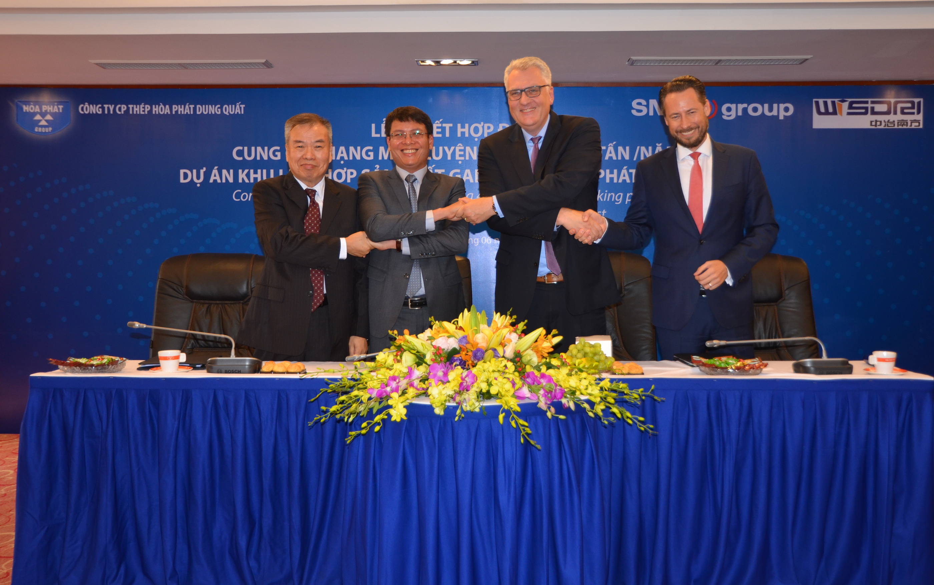
Signing of the contract for a converter shop in Vietnam.
From left to right: Mr. Ho, WISDRI; Mai Van Ha, Director Hoa Phat Dung Quat Steel JSC.; Dr. Guido Kleinschmidt, Member of the Managing Board of SMS group and Marc Hoffmann CEO & MD SMS India.

