Phone: +49 211 881-4449
Fax: +49 211 881-774449
Mobile: +49 151 40226502
E-mail: thilo.sagermann@sms-group.com
Thilo Sagermann

PRESS RELEASE

Düsseldorf, July 24, 2017

New dimensions with tolerance and quality improvements
for sections

Hyundai Steel Company orders new horizontal straightener for medium section mill from SMS group

Hyundai Steel Company, Seoul, Korea, has placed an order with SMS group (www.sms-group.com) for the supply of a straightening machine for the medium section mill at its Incheon site.

The new horizontal roller straightener of type HRM 1400/1250/1100-9M will replace the existing straightener installed in 1995. With this new horizontal straightener from SMS group, Hyundai Steel will be able in future to roll larger sheet piles and beams up to a web height of 450 millimeters. In addition to extending the product range, the straightener will also help to improve the tolerances and quality of the sections. This straightener type impresses also with reduced maintenance and lower media consumption while maintaining a high level of process reliability.

Commissioning of the straightener is scheduled for autumn 2018.

With a crude steel production of 24 million tons per year, Hyundai Steel is one of the ten largest steel producers worldwide, supplying predominantly to the automotive, shipbuilding and general construction industries.
(21 lines of max. 65 characters per line)
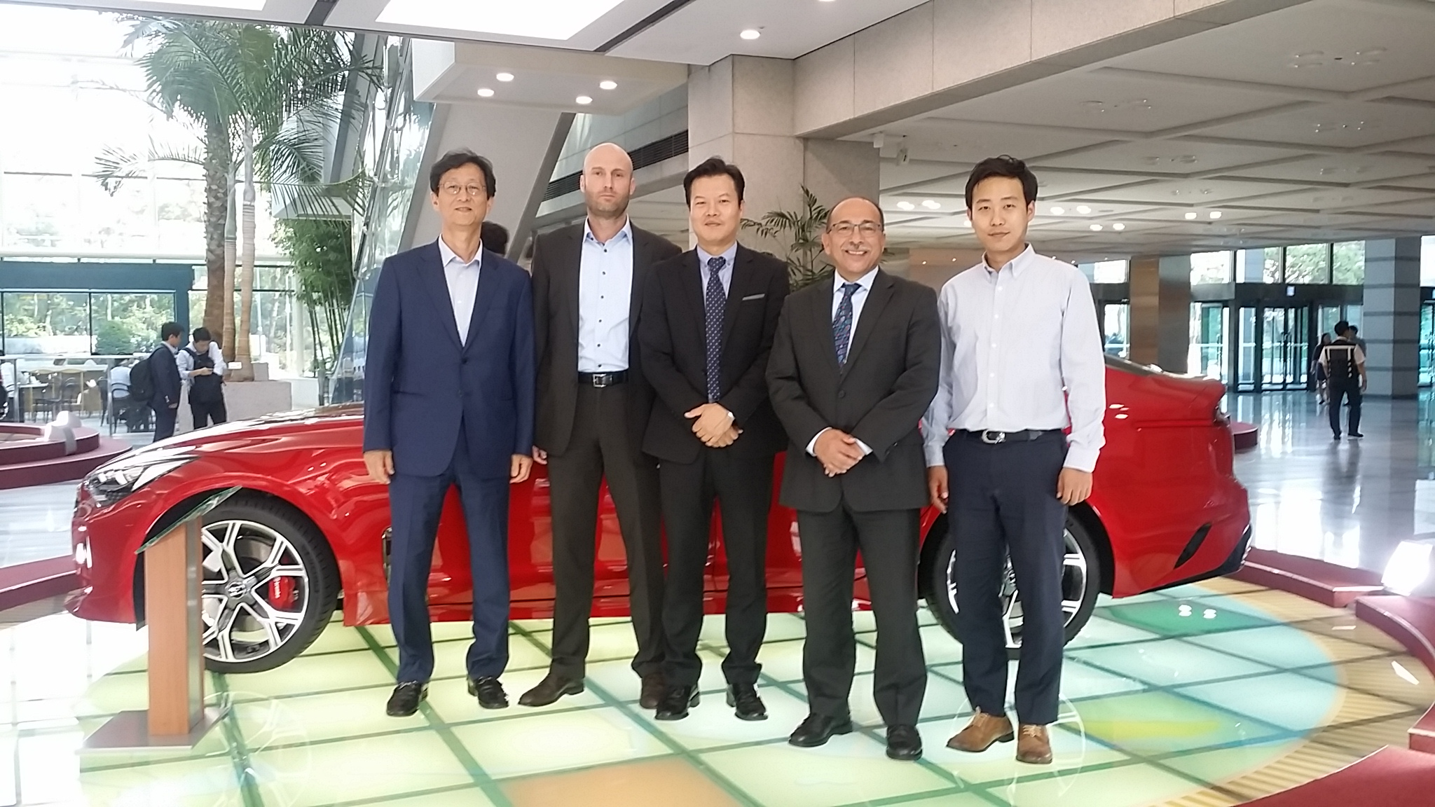
From left to right:
M.J. Jeon: President of CTC Clover Trading; Ralf Siewe: Project Manager Sales Section & Billet Mills, SMS group; T.H. Chung: Deputy General Manager of Equipment Procurement Team, Hyundai Steel Company; Carlo Melis: Commercial Sales & Contract Manager, SMS group; T.W. Park: Assistant Manager of Equipment Procurement Team, Hyundai Steel Company.

