For further information, please contact:
Samantha Joubert, Marketing Communications Coordinator
Tel: +27 11 821 3602 / Fax: 086 681 4342

Samantha.joubert@skf.com

For Immediate Publication
19th April 2017

Lincoln Lubrication and SKF showcase agricultural solutions at Nampo 2017

Lincoln Lubrication South Africa is showcasing its automated lubrication and Muster II fire suppression systems as well as parts and service solutions at Nampo 2017.

“We have supported Nampo for the past seven years, exhibiting jointly with SKF for the past two years when we became part of the global SKF group,” says Lincoln Lubrication’s Regional Manager, Jaun Herbst. The exhibition stand which is located in the main hall at Nampo will display Lincoln Lubrication’s automated greasing systems and Muster II fire suppression systems as well as SKF’s Agri hub and Yelag bearings. “The two companies’ complementary product portfolios provide farmers with the opportunity to conveniently source greasing systems, fire suppression, bearings and related accessory solutions from a single source supplier.”

Modern farmers are focusing more and more on the quality of products rather than on price as they realise that in good quality they find reliability, cost saving and uptime which subsequently leads to a return on investment and profitability. “Our comprehensive agricultural product solutions are delivering on all fronts,” asserts Herbst. Lincoln Lubrication’s products have been tested in agricultural markets around the world with great success and Herbst adds that a number of OEM’s have Lincoln Lubrication Systems fitted as a standard.

The local agricultural sector is a growing market for Lincoln Lubrication and presents untapped potential to provide solutions for a number of machinery reliability issues.
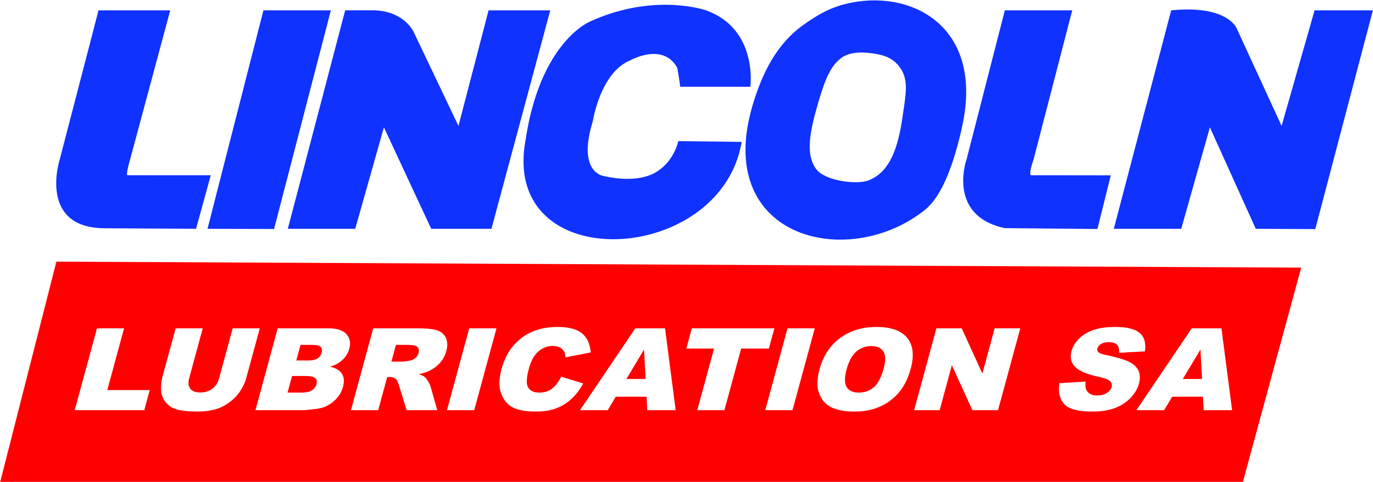
2/…Nampo 2017

2/…Nampo 2017
But the agricultural industry is not without its own inherent challenges. In order to successfully address this tough market it is important to have an understanding of the challenges faced by farmers.

“The three year drought that has gripped our country and which still continues in the Cape regions means that many farmers are not in a position to invest in new products or upgrades.

There is a direct correlation between profitability and production. When it comes to crop farming for example, farmers have a limited window period for planting and harvesting so costly breakdowns in the field are simply not an option. Farmers therefore depend heavily on equipment and system reliability which is paramount to uptime.

”Lincoln Lubrication’s automated lubrication systems which include single nipple greasing as well as fully monitored systems deliver fast accurate greasing for optimum equipment reliability. The lubrication specialist recently came to the assistance of a customer in the Free State who was experiencing problems with the greasing of his crop sprayer. “When greasing the machine during planned maintenance, some points were often missed while others were either over- or under-lubricated leading to equipment downtime,” explains Herbst. This not only wasted valuable time but also compromised equipment reliability. The farmer wanted a dependable system that gives him the assurance that all points are greased and that the correct quantities are delivered to each point.

“We recommended the single nipple greasing system as the best solution. Using distribution blocks we route all greasing points to one grease nipple, which enables lubrication of all points from one greasing point, eliminating the risk of missing any greasing points for complete peace of mind. In addition, the system also offers substantial time saving. The 45 minutes normally required to lubricate all 40 points on the crop spray is now reduced to a mere eight minutes as there are only seven greasing points that cover the whole machine with the exception of the rotational greasing point (prop shaft). Herbst adds that although this system is not fully monitored and automated, an electric pump can easily be added to the system without changing any configurations.

3/…Nampo 2017

3/…Nampo 2017

The farmer expressed extreme satisfaction with the product as well as with the professional and experienced service and onsite product training from Lincoln Lubrication. He was also impressed that he can conveniently deal with a single source supplier for both his bearings and lubrication system requirements.
Long-term customer relationships are of the utmost importance for both Lincoln Lubrication and SKF. “We believe in building partnerships with our customers and do not merely supply commodities; we support our products with parts supply, expert advice and training; our highly skilled technical team deliver specialist maintenance and after-sales service. As part of our customer service, we pay regular visits to our customers to ensure that our systems are in good working order.”

Lincoln Lubrication’s agricultural offering is available from SKF’s extensive Agri distribution network. “Product knowledge is extremely important so we are spending time with distributors and end-users, sharing product information and training. We have completed a number of Muster II fire suppression demos in the Free State which we plan to roll out across the country together with our successful crop spray system,” concludes Herbst. -ends-

SKF is a leading global supplier of bearings, seals, mechatronics, lubrication systems, and services which include technical support, maintenance and reliability services, engineering consulting and training. SKF is represented in more than 130 countries and has around 17,000 distributor locations worldwide. Annual sales in 2015 were SEK 75 997 million and the number of employees was 46 635. www.skf.com

® SKF is a registered trademark of the SKF Group.
™ BeyondZero is a trademark of the SKF Group.

By: Sonia Laverick
Laverick Media Communications cc
Tel: +27 (0) 11 0400 818
sonia@laverickmedia.co.za / www.laverickmedia.co.za

