For further information, please contact:
Samantha Joubert, Marketing Communications Coordinator
Tel: +27 11 821 3602 / Fax: 086 681 4342

Samantha.joubert@skf.com

For Immediate Publication
12th April 2017

Cost efficient grease solutions for sugar mills from Lincoln Lubrication

The excellent control and monitoring capabilities of Lincoln Lubrication South Africa’s high pressure Progressive lubrication systems deliver significant savings for South Africa’s sugar mills.

Progressive lubrication systems consist of a pump connected to at least one primary metering device. The pump supplies lubricant which can be oil, fluid grease, grease or compound, to the metering device which splits the lubricant into even or predefined amounts.

Lincoln Lubrication, part of the SKF group, has supplied a number of progressive systems to the local sugar industry for bearing lubrication on sugar mill trains located at the mill front ends. Lincoln Lubrication’s Regional Manager for Kwazulu Natal and Swaziland, Kevin Mills, says that the local sugar industry is facing a number of challenges. “In addition to the prolonged drought which has affected sugar cane quality and throughput, depressed sugar prices and stiff competition from other producing countries is placing severe pressure on local sugar producers’ revenues and profit margins with debilitating effects on plans for investment in refurbishing or expansion projects. Consequently capital expenditure over the last few seasons has focused on only what is deemed necessary for safe and economical operation.”

Kevin further points out that in an attempt to counter the high cost of lubricant for mill bearings, many mills are experimenting with different types and brands which can affect machinery reliability. “A seemingly inexpensive lubricant can, in the long run, cost the mill dearly in downtime to allow for repairs or replacement of damaged or failed machines.”
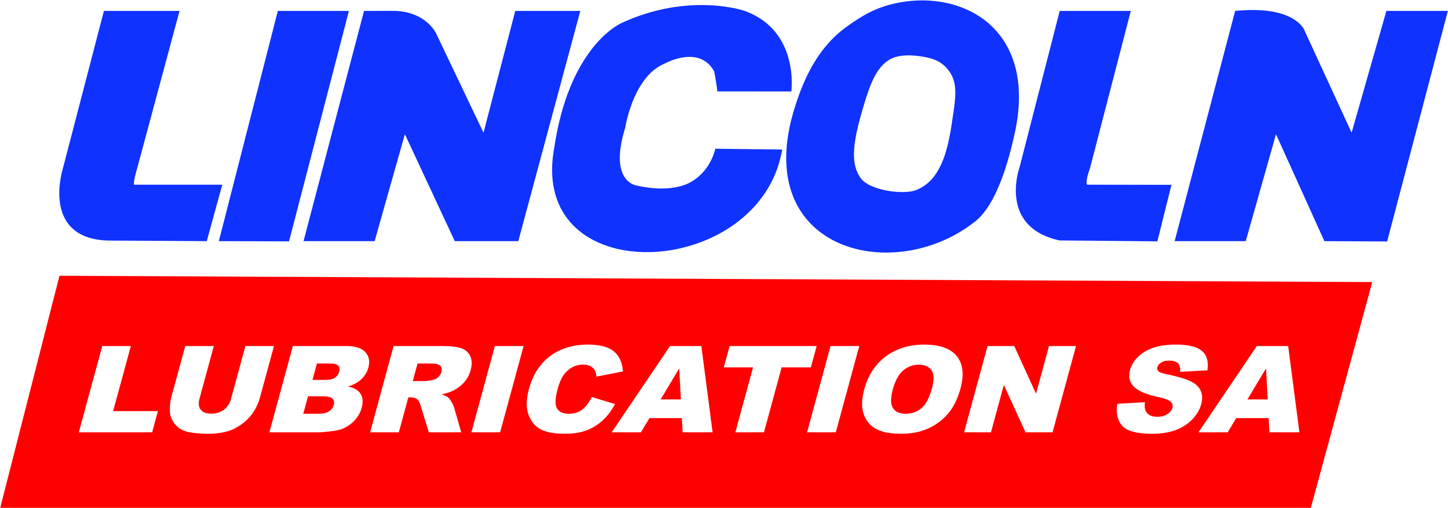
2/… _{Lincoln Lubrication}
2/… _{Lincoln Lubrication}

Most sugar mills do not have a single brand of lubrication system in use to cover all their lubrication requirements making it difficult to create a standard and maintain spares inventories. “With suitable repairs and maintenance back-up for the lubrication systems compromised, the resultant poor standards of lubrication system maintenance and lubricant management can result in contamination of lubricants and lubrication systems leading to premature failures of machinery and components,” notes Kevin.

“We are able to assist the sugar industry in nullifying these challenges with the installation of the High pressure Lincoln ZPU -02 progressive system with Powermaster 4 series 50:1 ratio high volume drum pump with auto filling capability.” In addition to eliminating lubricant wastage, constant control and monitoring further ensure reliable and correct lubrication supply which, by reducing the risk of mill roll bearings damage or failure optimises plant availability. Kevin adds that data download capabilities are also available from such systems, allowing constant analysis and trending of any system problems as well as indicating exact quantities of lubricants dispensed to the mill bearings.

The progressive system monitors mill bearing grease points for blockages/flow as well as grease levels in the lubrication pump reservoir. Analogue alarm signals are sent via a PLC to the mill control room for pro-active intervention by the maintenance team.

If low grease levels are detected in the filling station drum, the system sounds the alarm to avoid the ZPU-02 lubrication pump reservoirs from running low. Monitoring of the filling pump functionality ensures that the mill bearings receive grease at all times. The health of the lubrication pump is also monitored; the alarm alerts maintenance in the event that the pump stops functioning so that repairs can be performed immediately with minimum disruption to uptime.
The system also measures the amount of lubricant being consumed by the mill bearings. Proper metered dosages pumped to the mill bearings can reduce the mills’ overall grease consumption by as much as 30%.
3/… _{Lincoln Lubrication}

3/… _{Lincoln Lubrication}

With fourteen sugar mills in South Africa and three in Swaziland, Kevin says that challenges aside, there is still tremendous growth potential in the sugar industry.
“We have an aggressive growth strategy in place to harness these opportunities with our world-class lubrication technology.”

The Lincoln Quiklube P203 progressive system is ideal for the lubrication of centrifugal machines, sugar dryers, diffusers, cane loaders, cane haulers and excavators at sugar mills while Lincoln grease spray systems are suited to sugar mill drive and pintle gear lubrication. SKF oils circulation systems can be used on turbine-driven cane knives as well as on oil conditioning units for mill train gearboxes.

Lincoln and SKF Lubrication Systems solutions are available directly from Lincoln Lubrication South Africa as well as through the company’s network of authorised lubrication systems dealers or the SKF network of authorised industrial distributors.

-ends-

SKF is a leading global supplier of bearings, seals, mechatronics, lubrication systems, and services which include technical support, maintenance and reliability services, engineering consulting and training. SKF is represented in more than 130 countries and has around 17,000 distributor locations worldwide. Annual sales in 2015 were SEK 75 997 million and the number of employees was 46 635. www.skf.com

® SKF is a registered trademark of the SKF Group.
™ BeyondZero is a trademark of the SKF Group.

By: Sonia Laverick
Laverick Media Communications cc
Tel: +27 (0) 11 0400 818
sonia@laverickmedia.co.za / www.laverickmedia.co.za

