Phone: +49 211 881-4449
Fax: +49 211 881-774449
Mobile: +49 151 40226502
E-mail: thilo.sagermann@sms-group.com
Thilo Sagermann

PRESS RELEASE

Düsseldorf, February 15, 2017

New products for the Russian wheel and rail market

Metalloinvest places an order with SMS Concast for the revamp of a continuous caster at Ural Steel

SMS Concast, a company of SMS group (www.sms-group.com), has been awarded a contract by Metalloinvest, Russia, to modernize a four-strand continuous casting machine CCM-1 at metallurgical works “Ural Steel”. The aim of the upgrade is to enable the casting of round billets of 455 millimeters diameter for downstream manufacturing of railway wheels and the casting of rectangular billets in format 300 x 330 millimeters for the production of rails.

“The revamp of the continuous caster CCM-1 at Ural Steel will allow Metalloinvest to master the production of new types of high-margin products, to secure the company’s position in the market of high-end steel grades and to increase the production efficiency. The project investment totals to over 1 billion rubles,” said Andrey Varichev, General Director of MC Metalloinvest. Apart from the new equipment, such as foot rollers, segments, spray rings, needed for the new format, SMS Concast will introduce well-established technology; i.e. steel billets cast on the CCM-1 will be produced using CONVEX® mold technology, CONFLOW stopper control and CONSTIR, a new system of electromagnetic final stirrers. Electrical and automation systems are customized to integrate the new equipment and to optimize the continuous casting process. Pilot production is scheduled to begin in mid-2017.

(24 lines of max. 65 characters per line)

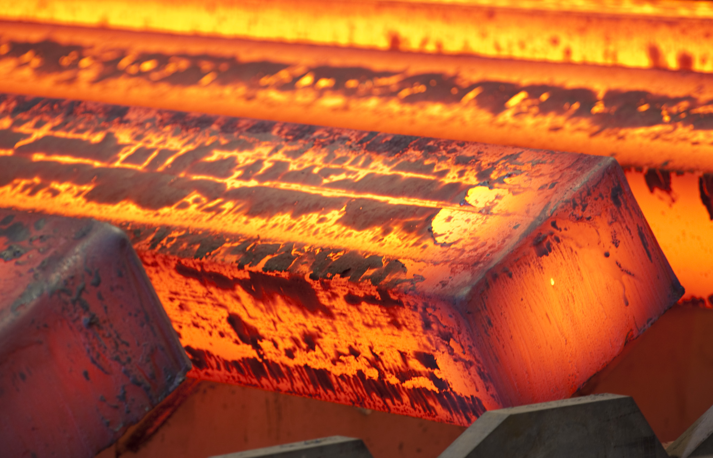
The modernization of the four-strand billet caster by SMS Concast enables Ural Steel to offer an extended product range for the wheel and rail market.

