Ingeteam launches its new 100 kW three-phase string inverter
- The inverter is to be showcased at the Solar-Tec fair in Cairo, Egypt
- Series production is set to commence in June 2017
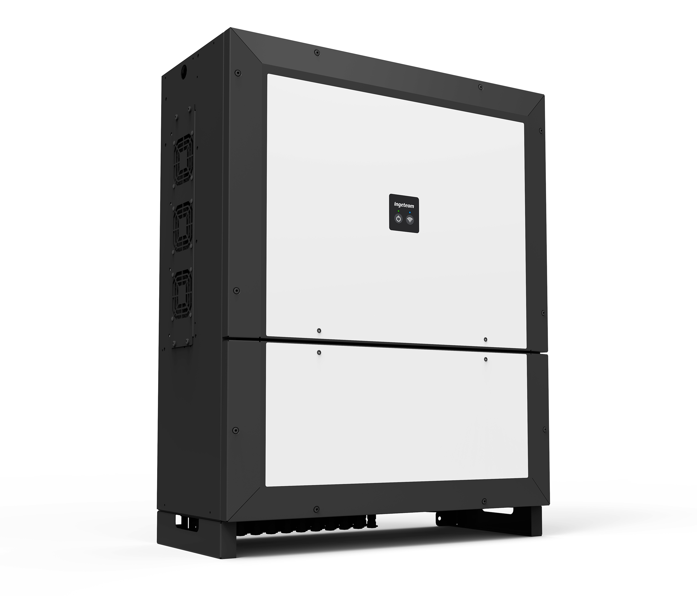
Pamplona. 29th November 2016. Ingeteam is finalizing the launch of its new PV string inverter, which will make it possible to achieve a power output of 100 kWAC in a single, 75 kg unit. This inverter will be on show at the Solar-Tec fair in Cairo (Egypt) from the 4th to 6th December, and is set to go into production in June 2017.
This new three-phase inverter, commercialised under the name INGECON SUN 100TL, is suitable for indoor and outdoor installation alike, and is primarily directed at commercial, industrial and large-scale projects.
Its main advantage over other models on the market lies in its significant cost savings potential, given the fact that its high power density means that it is possible to drastically reduce the number of inverters to be installed and, therefore, the total amount of cabling. Furthermore, no combiner boxes are required (either in DC or AC) and neither is a neutral cable necessary, thereby reducing the total AC cabling cost by up to 20%. All this leads to huge reductions in capital expenditures (CAPEX).
This inverter also means lower operating costs, thanks to the wireless communication which permits the startup, monitoring and control of the PV system through either a mobile phone, tablet or laptop. Furthermore, its string inverter philosophy guarantees minimum possible maintenance requirements, with no need to vacuum the inverter interior or to check the state of the fuses, the thermal magnetic breaker or torque.
In addition to its high power density, the inverter's main features include its high maximum efficiency (98.8%), Wi-Fi and Ethernet communications supplied as standard, maximum DC input voltage of up to 1,100 VDC and advanced grid support functionalities, with a low-voltage ride-through capability and reactive power capability. What's more, this inverter family is also suitable for three-phase self-consumption systems, with or without the injection of excess energy into the public grid.
Ingeteam is to showcase two different models for this PV inverter (STD and PRO) in order to adapt to its customers' needs and to the technical requirements of as many projects as possible.
The 3Play family models available up to now, with output powers ranging from 10 to 40 kW, are already installed in countries such as Switzerland, Italy, Argentina, Paraguay, France, Australia, Chile, India, El Salvador, Brazil, Mexico, United States, Lebanon, Turkey, Pakistan and Spain, to name but a few.

Ingeteam
Ingeteam is a leading company specializing in the design of power and control electronics (frequency converters, process automation and control systems), electrical machines (generators and motors), electrical engineering and generating plants. To date, Ingeteam has supplied 39 GW in power converters for renewable energy plants and is amongst the TOP 10 companies dedicated to the operation and maintenance of that kind of plants, with a portfolio of more than 7.2 GW.
The company operates in all continents, and has a headcount of around 3,700 employees around the world. Ingeteam invests 7% of its annual turnover in R&D, which is the backbone of the company's business activity.
For more information:
http://www.ingeteam.com/en-us/energy/photovoltaic-energy/p15_24_333/is-3play-100kw.aspx

Follow us on:    

