Phone: +49 211 881-4449
Fax: +49 211 881-774449
Mobile: +49 151 40226502
E-mail: thilo.sagermann@sms-group.com
Thilo Sagermann

PRESS RELEASE

Düsseldorf, November 15, 2016

High-quality steel for the automotive and mechanical industry engineering industries

Bangkok Iron and Steel Works provides FAC for new meltshop to SMS group

Together with SMS group (www.sms-group.com), Bangkok Iron and Steel Works (BISW), Thailand, successfully commissioned a new meltshop for the production of high-quality steel grades. Within the city of Bangkok, SMS group supplied a 60-tons ladle furnace, a
60-tons vacuum degasser, a 3(4)-strand continuous billet caster for billets 150 millimeters and 130 millimeters square as well as a fume treatment plant. The new steelworks with the equipment from SMS group assure BISW the production of high-quality steel, attaining roughly 400,000 tons per year.

“With SMS group technology we are now able to produce exactly the products our customers need, whilst staying at a competitive cost level and in line with the latest environmental directives,” says Dr. Nantawatchai, General Manager at BISW.

The new equipment allows BISW to cover the steel production ranging from low to high carbon grades and helps BISW to penetrate the domain of special steels and offer products for particular applications in the automotive and mechanical engineering industries.

(21 lines of max. 65 characters per line)
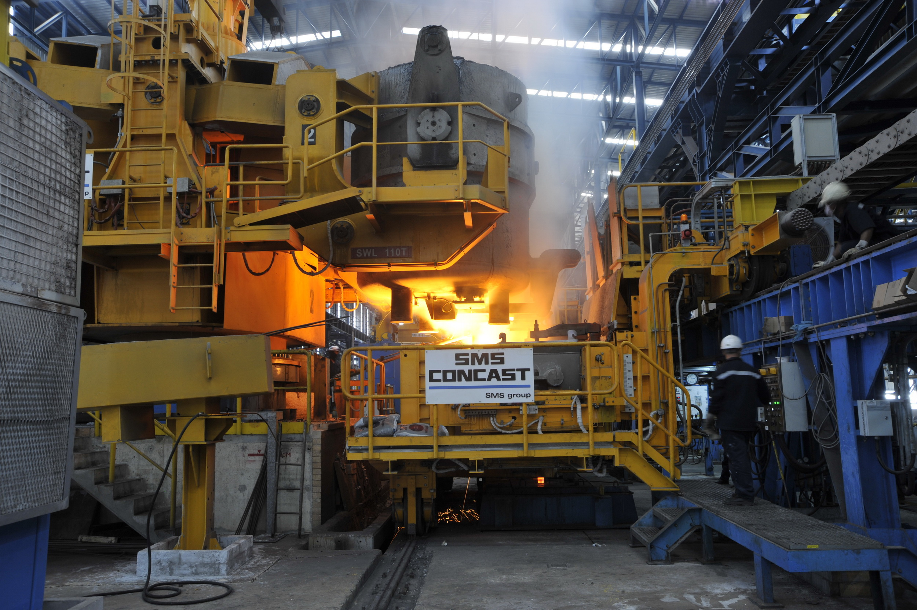
Casting of steel on the new continuous billet caster of SMS Concast assures
BISW in Bangkok a high production output.

