Phone: +49 211 881-4449
Fax: +49 211 881-774449
Mobile: +49 151 40226502
E-mail: thilo.sagermann@sms-group.com
Thilo Sagermann

PRESS RELEASE

Düsseldorf, September 7, 2016

Everthing supplied from a single source

SMS group to supply two new wire rod mills to Guangdong Guoxin Industrial

Chinese Guangdong Guoxin Industrial Co. Ltd. has awarded SMS group (www.sms-group.com) the order to supply the mechanical core components and the complete electrical and automation package for a new wire rod mill complex. The new complex will be built in the Sino-German Development Zone, Jieyang City, Guangdong Province, with production scheduled to commence in 2017. The works will be designed for an annual capacity of 1.4 million tons (700,000 tons per year per mill). The two one-strand high-speed mills will roll wire rod in diameters from 5.5 to 25 millimeters and rebars in diameters between 6 and 14 millimeters at rolling speeds of up to 105 m/s. The steel grades to be rolled will comprise cold-heading, alloyed, spring and stainless steels as well as tire cord and welding wire.

As core equipment both wire rod mills will feature compact cantilever stands (CL stands) in the intermediate mill, six- and four-stand wire rod blocks and a loop laying head. The CL stands will be of identical design and exchangeable with one another. SMS group will supply their tried-and-tested and reliable wire rod blocks in six- and four-stand design. The division into two blocks means that all final dimensions can be finish-rolled in a maximum of four passes. All dimensions can therefore be rolled thermomechanically, i.e. at low temperatures and with close dimensional tolerances.

Besides the mechanical equipment, SMS group will supply the complete electrical and automation package, from the roller table at the exit end of the reheating furnace down to the coil transfer system, and perform the commissioning activities. The supply scope includes the technological control systems for the automation, the switchgear, drive system, sensor technology and HMI system.

To allow an optimized cooling strategy to be conducted for each steel grade, the CCT® model (Controlled Cooling Technology) developed by SMS group will be implemented in combination with an automated control system for the water cooling sections.

(35 lines of max. 65 characters per line)

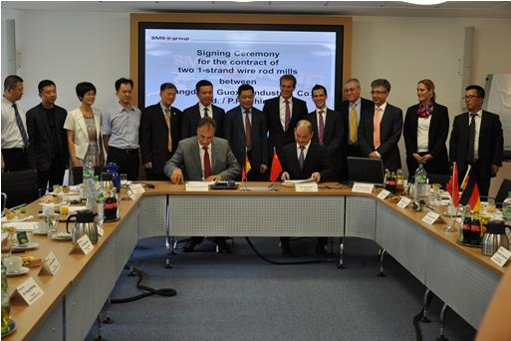
Burkhard Dahmen, (left), Chairman of the Managing Board of SMS group GmbH,
and Huang Min, Chairman of Guangdong Guoxin Industrial Co. Ltd., signing the contract.

